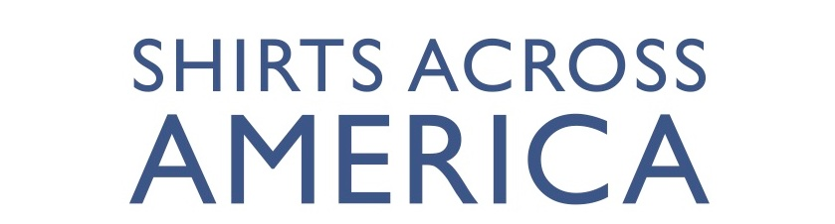

SAA Code of Conduct
- All participants represent Shirts Across America at all times and must not present themselves in a way that is detrimental to the reputation of Shirts Across America or its school partners.
- All participants will conduct themselves in a courteous and respectful manner.
- All participants wll abide by any curfews established by Shirts Across America Staff.
- All participants will treat each other with dignity and respect. Harassment, threats, or bullying of any participant or staff will not be tolerated
- Youth participants are subject to the authority of the Adult Team Leads and will follow their direction and instruction at all times. If a youth has any concern about the behavior of other participants, they must bring the concern to an Adult Team Lead or Shirts Across America Staff.
- Regardless of age, no alcohol is permitted for any participants throughout the Event. Adults may not use, possess, or be under the influence of any alcoholic beverages over the course of the Event, even when youth are not present.
- No Adult Team Lead will leave their team without supervision at any time during the Event. If an adult needs some personal time/short break, they must ask Shirts Across America Staff to assist with temporary help.
- All participants are prohibited from inappropriate phone and social media use. This includes but is not limited to:
  - Taking pictures or recording any other kind of media in bathrooms or other spaces where such recording would violate another person’s privacy
  - Posting inappropriate or explicit content on Social Media
  - Disrepecting or antagonizing a fellow participant or other person using Social Media or any other means
- Examples of other kinds of prohibited behavior for participants are, but not limited to:
  - Criminal behavior or violation of local laws
  - Any form of sexual harassment
  - Disorderly, indecent, or obscene conduct, gestures, or actions
  - Abusive language
  - Violent behavior
- Failure to observe this Code of Conduct may result in dismissal from the Event. Any person dismissed will assume and pay for all transportation and other costs resulting from the dismissal and reimburse Shirts Across America for any charges, penalties, or expenses incurred.

